 | The CAMECA IMS 7f and 4fE7  Normal Electron Gun (NEG) user’s guide  00 45 633 907 - Type 108 – Indice A
0000.doc
Index

Contents
1. Introduction 1
2. NORMAL INCIDENCE ELECTRON GUN 1
2.1 ELECTRICAL CHARGING EFFECTS 1
2.2 NEG DESCRIPTION 4
2.3 ELECTRON BEAM COLUMN ALIGNMENT 5
3. EXPERIMENTS 14

Introduction
This IMS 7f and 4fE7 NEG user’s guide is a complement to the IMS 7f and 4fE7 ion optics user’s guide.
Contents ↑

NORMAL INCIDENCE ELECTRON GUN
This section is divided into four parts. The first recalls the physical processes, which cause electrical charging effects during SIMS analysis. The second is a physical description of the normal incidence electron gun (NEG). The third includes procedures to perform the alignment of the electron beam column. The fourth describes the experimental procedures to perform analysis on insulating samples. In each part, two cases will be independently considered: analysis of positive and negative secondary ions.

ELECTRICAL CHARGING EFFECTS
During SIMS analyses, positive, negative or neutral primary particles impinge the sample surface and either positive secondary ions or negative secondary ions, and secondary electrons, leave the sample surface.

As the yields secondary ions/primary ions and secondary electrons/primary ions are not equal to 1, it is clear that an excess of charge will occur over the sputtering area. If the sample has an intrinsic conductivity, the excess electrical charges can flow towards the conductive sample holder and the potential of the surface will be kept constant. On the other hand, if the sample is an insulator, the electrical charges accumulates on the sample surface and the potential surface is modified positively or negatively, depending on the sing of charges appearing over the sputtering area.

Contents ↑
POSITIVE MODE
In order to collect positive secondary ions, the sample is brought at a positive potential (e.g. +5 kV). In that case, only positive secondary ions can escape from the sample surface and leave behind negative charges (secondary electrons and negative ions being trapped on the sample surface by the strong extraction field). The number of charges Q+ appearing on the sputtered area per incoming primary particle is therefore given by the relationship:

Q+ = qp + qs Y+ (1)

where:

qp Is equal to 0 or neutral, +1 for positive and -1 for negative primary particle (only single charged primary ions are considered).

qs Is the sign of the charges left behind by the secondary ions.

Y+ Is the yield for positive secondary ions/primary particles. This yield is always less than 1.

Equation 1 shows that for the use of positive primary ions, a positive charge is building up on an insulating material, and for negative primary ions or neutral (FAB), it is a negative charge. In fact, to give a complete description of the phenomena occurring in positive mode, secondary electrons coming back from the front plate of the immersion lens should be also considered, but, in first approximation, they can be neglected.

NEGATIVE MODE
In order to collect negative secondary ions, the sample is brought at a negative potential (e.g. - 5 kV). In that case, negative secondary ions and secondary electrons can escape from the sample and leave behind positive charges where the positive secondary ions are trapped on the sample surface by the extraction field. In negative mode, equation 1 therefore becomes:

Q- = qp + qs ( Y- + Ye ) (2)

where:
Y- Is the yield for negative secondary ions/primary particles, which is always less than 1.

Ye Is the yield for secondary electrons/primary particles, which is always more than 1.

Equation 2 shows that in negative mode whatever the primary particles are, a positive charge is building up over the sputtered area. The following table summarizes the different cases which can occur for an insulator analysis:

 | Secondary Ions | Primary Ions | Charging Up
1  2  3 | +  +  + | Neutral  ⎯  + | < 0  < 0  < 0
4  5  6 | ⎯  ⎯  ⎯ | Neutral  ⎯  + | > 0  > 0  > 0

The above shows that depending on the experimental conditions (polarity of secondary ions), the sign of electrical charging can be either positive or negative. If no charge compensation is carried out, the potential of the sputtered area will exceed the nominal value 5kV and, therefore, no secondary ions will be collected since the mass spectrometer is adjusted to analyze ions accelerated under 5 kV.

In order to keep the surface potential of the analyzed area constant when a positive charge occurs, a flood of electrons may be used for charge compensation. But, for negative charging effects, no charge compensation is possible by using an electron gun.

However, it must be noted that the use of neutral or negative primary particles for positive secondary ion analysis enables one to perform SIMS analysis of insulators, even if negative charge builds up. As a matter of fact, low density of neutral or negative primary beam allows one to reach a steady state with negative charging corresponding to a few tens of volts, which may be compensated by applying an offset on the sample holder.
Contents ↑

IDENTIFICATION OF CHARGING EFFECTS
When an analysis is performed on an insulating material, it is important to know if the charge compensation works well. Of course, a high voltage sample breakdown is an obvious indication of incorrect charge compensation. However, sometimes there is no HV breakdown but charging effects are present. To check this the adjustment capability of the width and the position of the energy slit may be used.

For example, by closing the energy slit, the energy band pass may be reduced to 1eV. In that case, looking at the direct ion image, if the variation of the surface potential is more than 1 Volt over the imaged field, contrast (darker area) will occur indicating the presence of charging effects.

Another criterion to identify charging effects is the shape of the secondary ion energy distribution. On a conductive sample when a narrow energy slit (a few eV) centered on the peak intensity of the energy distribution is mechanically pulled towards the low energy ion side, the secondary ion intensity decreases to zero for a small shift (corresponding to 5-10eV). On an insulating material, when there are charging effects, the energy distribution is deformed. So that, by pulling the energy slit over the complete range (125eV) if null secondary ion intensity is never reached, this proves that the charge compensation is not correct.

NEG DESCRIPTION
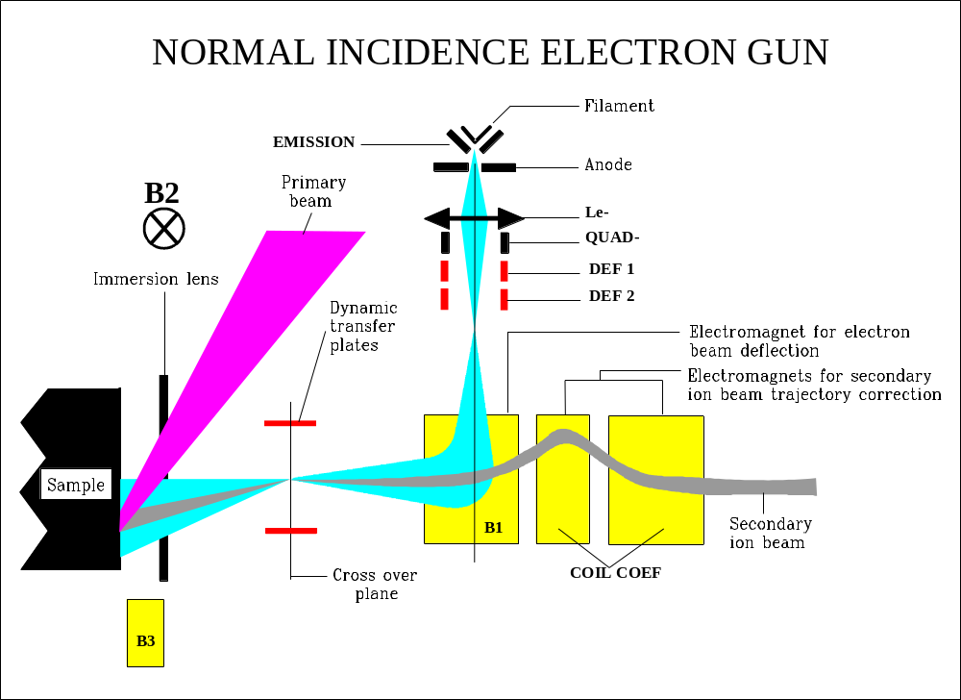The figure below shows a schematic drawing of the normal incidence electron gun. The electron source is a tungsten filament (which can be brought to a potential adjustable between 0 and -5kV) and a Wehnelt. The column of the electron gun is composed of one einsel lens, one quadrupole lens (acting as a deflector), a deflector and a magnetic sector (B1). This optical system is adjusted to form a cross-over for the electron beam in the cross-over plane of the secondary ions (formed by the immersion lens in the rotation center of the dynamic transfer plates). The immersion lens is, therefore, going to bring electrons towards the sample surface with a focalization effect depending on how it is energized.

IMS 7f and 4fE7 Normal Incidence Gun (NEG)

In negative mode, making use of the reversibility principle, it is clear that incoming e- will follow the same trajectories than the secondary ions. And, if electrons go through the crossover plane on the secondary optical axis, they will arrive on the sample surface with a normal incidence and energy close to zero since the potentials of the filament and the sample are the same. In negative mode, the electron beam is about 125µm in diameter.

In positive mode, the immersion lens potential is positive so that it will act as a lens working in the accelerating mode for the electron beam. In that case, a defocused electron beam will be obtained on the sample surface with a beam diameter lower or equal to 750µm (the size depending on the accelerating voltage of electrons and an energy equal to the sum of the sample voltage and filament voltage.

Three other magnetic fields are required to setup the electron gun: B2 and B3, which are used to center the e- beam along the X and Y directions on the sample surface; and COIL COEFF, which compensates the deviation of secondary ion beam undergone in the B1 sector. Note, that the X and Y directions of the electron gun are not the same as the sample movement axes. The electron gun axes are rotated on 45-degree counterclockwise compare to the sample orientation axes.
Contents ↑

ELECTRON BEAM COLUMN ALIGNMENT

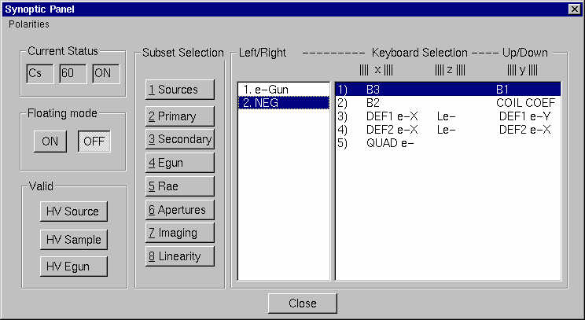

PRELIMINARY

Before any electron gun adjustment at a given secondary extraction voltage, it is required to check that relative adjustment between the two magnetic fields B1 and COIL COEF is correct. To do this, proceed as follows:

q Set B1 and COIL COEF at 0 on the keyboard

q Get a secondary ion image using a test sample grid.

q Adjust the secondary magnetic field to select the mass 1 (Hydrogen image).

q Apply the B1 value required to deflect the e- beam on the secondary ion optical axis (For instance B1 =2100 for HV sample= 5 kV). The hydrogen image will be defocused. This is due to a shift of the cross over in the contrast aperture plane.

q Adjust COIL COEF in order to get back a nice focused H image (Don’t change the contrast aperture position or voltage on the DTR3 deflectors)

q Press VALID + e- HV button on the SYNOPTICS main box (E-BEAM must be turned ON, otherwise the massage E-GUN IS NOT AVAILABLE should appear)

q

Contents ↑

ELECTRON BEAM CURRENT
The alignment of the normal incidence electron gun is performed in order to get the higher electron beam current with a beam diameter at least as large as the sputtered area and well centered on it.

The maximization of the electron beam intensity will be performed using the sample current measurement.

With the primary beam turned off and using a conductive sample, the sample current measurement enables one to measure the electron beam intensity. Excessive secondary electron emission and the lack of electrons reaching the sample surface will inhibit this measurement. Thus, the conditions of a right electron beam current measurement will depend upon the secondary ion polarity.

POSITIVE MODE:
In this mode, the sample holder is brought to a positive voltage, and electrons reach the sample surface with energy of at least 1-5kV (See below the figure Electron Beam in the Positive Mode). The sample current display therefore indicates a true electron beam current whatever the conductive sample fitted into a sample holder. As a matter of fact, due to the extraction field, primary electrons reach the sample surface and secondary electrons cannot escape from the sample.

NEGATIVE MODE:
The sample holder is brought at a negative voltage. In this case, it has been seen that a conductive sample surface acts as a mirror for primary electrons (See below the figure Electron Beam in the Negative Mode). The sample current measurement therefore indicates zero.

To allow electrons to reach the sample surface, the sample voltage must be adjusted to a less negative value than the filament (for example, - 4980V if the sample holder is at 5000V); electrons have impact energy of 20eV. In this case, electron beam current can be measured, but in fact, this value is wrong due to the emission of secondary electrons.

We described how to measure the e- beam current, but it is very important to remember that to perform a charge compensation, the electron beam has to be centered with primary beam on the sample surface; the primary beam position itself being on the secondary optical axis. The optimization of the electron beam current must therefore be carried out with the Faraday cup hole centered on the secondary ion optical axis.

Contents ↑

ALIGNMENT OF ELECTRON BEAM COLUMN IN NEGATIVE MODE
A complete procedure, described below, must be followed after maintenance of the e- gun (filament change) or when it seems that the performance for insulator analysis is not as good as it was before.

Complete Procedure:

q Start the instrument to analyze negative secondary ions.

ELECTRON BEAM IN POSITIVE MODE | ELECTRON BEAM IN NEGATIVE MODE
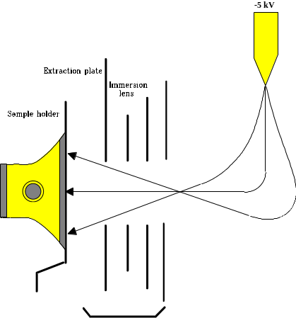 | 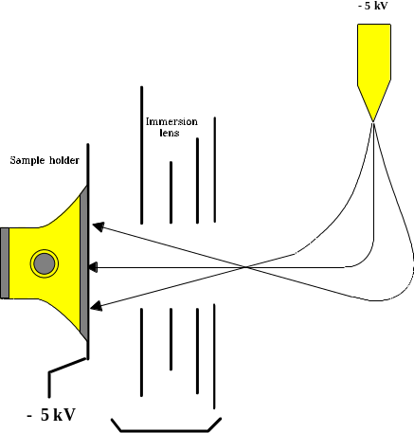

q Restore an ISF (refer to the Tuning Software user'guide), which contains parameters for electron gun column alignment. The file provided with the instrument contains an NEG setting for secondary accelerating voltage of -5 kV.

q Get a good secondary ion image.

q It is assumed that the secondary ion optics axis is known (e.g. with the laser spot).

q Drive the stage to the Faraday cup position and center the hole onto the secondary ion optics axis.

q Start the electron gun source (refer to the Tuning Software user'guide). Each instrument is delivered with at least one ISF containing standard conditions for the electron gun running. It is a good starting point for any new setting of the electron gun.

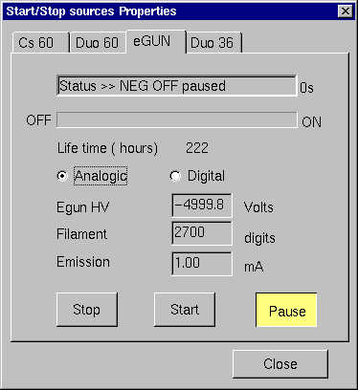

q Open the SYNOPTIC box (Secondary/NEG) for selecting and tuning the different NEG parameters in combination with the Real Time Screen. Read the filament voltage. If it corresponds to the desired value, go to the next step. If not, adjust the filament high voltage. Then execute the command VALID + e- HV (SYNOPTIC box). All parameters of the electron gun column (deflectors, quadrupole, lens, magnetic field) are readjusted to be consistent with the new electron accelerating voltage by extrapolating values from the current settings. A good starting point is therefore provided for the alignment at the e- HV.

q Click e- ON (Main Tuning menu bar) to switch on the electron beam onto the sample.

q Check that the Wehnelt voltage is at zero; display e- wehn and you should read 4095 bits for e- bias on the keyboard display.

q Read the electron gun emission current. If it corresponds to the desired value, go to the next step. If not, adjust it by adjusting e- fil. A standard value for the electron gun emission current is about 2 mA. To reach this value, the filament current read on the Real Time screen should be set approximately to 3.7 A for a new filament (3.3 A for an old one) at -5 kV filament voltage. Monitor the secondary vacuum value in the spectrometer. Work between 10-8 and 10-6 mbar.

q Increase the energy of electrons by applying a positive offset on the sample voltage +20V. (SYNOPTIC box, secondary/sample voltage)

q Try to maximize the electron beam current: firstly, by using B1, B2 and B3 for centering the e- beam in the Faraday cup hole, then using the Einzel lens Le-, the quadrupole QUAD e- and the deflectors DEF1e- and DEF2e-. Repeat these adjustments until a maximum is reached.

q Use the Wehnelt effect to increase the sample current, if possible, and look again for a maximum using B1, B2, B3, DEF1x, DEF1y, and QUAD e-.

q After several optimizations, a maximum electron current of at least 80µA should be obtained (at -5 kV filament voltage).

? Note: For this current maximization, the Faraday cup is not moved, but B3 and B2 are used to center the electron beam.

As B1 is modified by the small steps during the optimization, one does not need to readjust COIL COEF each time B1 is changed, but do not forget to set COIL COEF to the right value at the end of the procedure!

At this step of the NEG alignment, an electron beam reaches the sample surface with intensity high enough for charge compensation, and is centered on the secondary optical axis. Although, the shape of the electron beam and it’s the fine centering must still be checked.

q Move the stage to a grid test sample.

q Go back to the nominal value of the sample holder voltage.

q It is important to check if the filament and sample voltages are exactly the same because even if the Real Time Screen indicates equal voltages due to their accuracy, a deviation of a few volts may exist. Apply a negative offset on the sample holder (-20V) to be sure that electrons are reflected before reaching the sample (null sample current). Go back to the nominal value in one-volt step. At a given sample voltage, electrons are detected on the sample (the right digit on the voltmeter changes by one unit); this indicates that filament and sample voltages are equal.

q If the sample voltage display is no longer the nominal one (for instance 5000 V), it means that the filament and sample voltage measurements are not in accordance. As the secondary ion optics have been adjusted for a sample voltage display of -5000 V, electrons with null energy are obtained for HV sample = -5004 V; therefore, the right HV filament display will be -4996 V when -5000 V is read on the sample voltage voltmeter.

? Note: The disagreement between the two measurements should not exceed 10V. Otherwise, re-calibration is necessary.

q Get a direct ion image for hydrogen induced by primary ion bombardment with a Maximum Area of 150 µm.

q Switch OFF the primary ion bombardment.

q Adjust the electron energy at 10eV (applying a 10V offset on the sample voltage) and open the energy slit for an energy band pass of at least 50eV. Electron bombardment induces hydrogen desorption from the sample surface. A part of the hydrogen atoms leaves the sample surface as H- species; therefore, a direct ion image is formed on the fluorescent screen. This image provides a direct way to watch the e- beam shape and centering. By using lenses and deflectors, try to get the most uniform image of hydrogen and adjust the centering by using B2 and B3.

While these adjustments are performed, one must take notice that contrast, which is observed, is due to electron beam itself and not to hydrogen distribution on the sample surface. This is checked by moving the sample if the contrast of the hydrogen image remains the same whatever the sample position; it is the distribution in the electron beam which is imaged.

After this, tuning an electron beam with a homogeneous density over 100 -125µm in diameter should be obtained.

? Notes: The parameter values read on the display of the keyboard should not be much different (few tenths of bits) between optimization of electron beam current using the Faraday cup and optimization to have the better beam shape looking at hydrogen desorption.
It must be emphasized that with the grid test samples, the sample current is much less than with the Faraday cup for the same electron energy. This is because there is an important secondary electron emission from the sample. Generally, a sample current of 40 µA in the Faraday cup will give a current between 5 and 20 µA on the test samples. If adjustments to get the right shape and centering of the e- beam lead to a sample current less than 5µA for different sample positions, this could indicate that a right beam shape has been obtained to the detriment of the electron beam intensity. In that case, it is better to introduce again the Faraday cup and try to find a better alignment by repeating the complete procedure.

q Go back to the nominal sample holder voltage.

q Take note of the values of the different parameters giving a correct electron beam alignment.

The NEG is then ready to perform insulator analysis in the negative mode. Save an ISF (refer to the Tuning Software user'guide) so that at a later time this NEG status can be restored. Typical parameter values (in bits ) for -5 kV accelerating voltage are reprinted in the here under table:

 | e- heater | 2900
 | e- bias | 500
 | Le- | 1500
 | Quad | -40
 | B1 | 2100
 | COIL COEF | 700
Contents ↑
Routine Procedure:

The reproducibility of adjustments for the alignment of the NEG is very good. Therefore, after a complete alignment following the above procedure, and a save ISF operation, a fast start is possible.

q Start the instrument.

q Load an ISF corresponding to the NEG working.

q Move the stage to a grid test sample.

q Get a good image for hydrogen.

q Check that the filament of the electron gun and the sample are at the same voltage following the procedure for a complete alignment.

q Apply a 10V offset on the sample holder, and looking at the hydrogen image induced by electron bombardment, adjust finely the beam centering (by modifying slightly B2, B3.

q Apply a 20V offset and check that the sample current is at least 10 µA.

q Go back to the nominal sample holder voltage.

q NEG is now ready for charge compensation.
Contents ↑

ALIGNMENT OF ELECTRON BEAM CURRENT IN POSITIVE MODE
Regarding the NEG adjustment, the two main differences between positive and negative modes is that for the former, there is no self-compensation so that the filament voltage can be adjusted over the range 0 to -5000 V, and there is no secondary electron emission from the sample surface that allows one to measure electron beam current directly on any conductive sample.

It must be noted that for the same filament voltage the adjustments for a correct alignment of the NEG are nearly the same in negative and positive modes. The negative setup determined during the complete alignment procedure for negative mode can be used as starting conditions for daily use in positive mode.

Complete Procedure:

q Adjust the instrument for positive secondary ions, and set on the electron gun hardware if not yet made.

q Adjust the filament voltage at the desired value. Execute the command VALID + e- HV to set all electron gun parameters centered with the new filament voltage.

q Click e- ON and check that the Wehnelt (Emission) is set to 4095. Increase the filament current until an emission current of 2mA is reached.

q Using B1, B2, B3, Le-, Quad e-, DEFx, DEFy and Emission, maximize the sample current. An electron beam current of at least 30µA must be obtained.

q Switch ON the primary ion beam on the sample.

q Select the mass 27 if the test sample is the Al/Cu grid (or 28 if it is a silicon grid)

q Adjust the immersion lens voltage to get a good grid image. If there is a high electron beam current (>10µA) reaching the sample, the immersion lens voltage must be increased. This is due to high electron density going through the immersion lens, which affects equipotential lines in this lens.

q Adjust the secondary magnetic sector to select either the mass 1 (H+) or 19 (F+).

q Switch OFF the primary beam from the sample.

q The hydrogen or fluorine desorption induced by electrons provides a direct ion image allowing one to check the centering and the homogeneity of electron density. The centering is performed using B1. B2 and B3 have a lesser effect in positive mode than in negative mode since electrons have a much higher energy when they reach the sample surface.

q If electron gun alignment is correct, the imaged field of 150 µm must be completely illuminated while looking at the H or F desorption image. The entire electron beam can be observed using the optical microscope when a fluorescent sample is fitted into the sample holder.

q Save the ISF (refer to the Tuning Software user'guide).

Contents ↑

Routine Procedure:

q Start the instrument for positive secondary analysis.

q Restore an ISF corresponding to the NEG working at the desired secondary accelerating voltage.

q Looking at a fluorine image, adjust the e- beam centering. For any adjustment of B1, COIL COEF has to be readjusted.

q The NEG is then ready for positive insulator analyses.

NEG TURN-OFF PROCEDURE

q Refer to the Tuning Software user'guide.

EXPERIMENTS
In this section are described the means of adjusting the experimental conditions and how to start an analysis of insulating samples. Here again, the negative and positive cases are considered independently.

NEGATIVE MODE

Requirements for charge compensation:

As noted above in the Section § Electrical Charging Effects, in negative mode, whatever the nature of primary bombardment is (i.e., positive, negative or neutral), the charging effect is positive.

Let us consider a conductive film covered with an heterogeneous insulating film of two materials A and B (See below the figure Charge compensation in a heterogeneous sample) . The intensity of primary electrons (Ipe) is required to compensate for the arrival of positive primary ions (Ipi) plus the departure of negative ions (Isi) and secondary electrons (Ise) which is different in the two materials A and B. Thanks to the cloud of low energy electrons above the surface, the materials A and B will pick up the exact amount of electrons to compensate charge-up effects and excess electrons will be reflected (Ire).

The above considerations show that self-compensation mode works only if an excess of electrons is present above the sample surface. As the electron beam has a given electron beam density, this will involve requirements regarding adjustments of primary ion bombardment.

For example, the electron beam is about 100µm in diameter and the current is 50µA. This gives an electron beam density of 500mA/cm2. With the cesium microbeam source, the density for an ion beam of 20nA may be about 50mA/cm2. Let us consider two cases:

q Secondary electron / primary ions yield for A and B varying from 1 to 5. The electron beam density is therefore high enough to perform this analysis since an electron beam density higher than 250 mA/cm2 is required to have an excess of electrons.

q Secondary electrons / primary ions yield between 1 and 10. An electron beam density of at least 500 mA/cm2 is required. The NEG does not provide enough electrons in that case. Two solutions are therefore possible: increase the electron beam density by increasing the HV emission current, or reduce the primary beam density.

It has been shown that a buffer containing an excess of electrons is a prerequisite, but self-compensation will only be achieved if these electrons have a low energy. In order to better understand this second requirement, lets assume that the primary beam is OFF when the electron beam is switched ON.

It is known that the electronic yield (number of secondary electrons produced per primary electron) depends on the impact energy of the primary electrons, as well as the matrix, which is bombarded. As an example, the figure below electronic yield variation shows a typical variation of the electronic yield as a function of the impact energy.

If the impact energy of the electrons is higher than E2, the sample takes a negative charge and the impact energy of the primary electrons (Ep) decreases up to E2 where equilibrium is reached. When the ion beam is switched ON, additional negative charges leave the sample. This corresponds to an increased Ep making R decrease up to an equilibrium where Ipe = Ipi + Isi + Iise + R x Ipe. Iise are the ion induced secondary electrons and R x Ipe the electron induced secondary electrons. This equilibrium is not reached for the same energy (sample voltage) in the two materials A and B. This working mode has several drawbacks: high risk of breakdowns, electron irradiation damage that could induce ion drifts, sensitivity of the surface potential to primary beam intensity variations, non-uniform surface potentials on heterogeneous sample.

If the impact energy of the electrons is between E1 and E2, more electrons are leaving than entering. The surface potential becomes less negative, and Ep increases until E2. When the ion beam is switched ON, the same phenomena occur as in the previous case.

If the impact energy is below E1, R is lower than 1, more electrons are entering than leaving; in consequence, a negative charge is growing until the surface reaches the potential of the filament; the electron beam is then reflected. A cloud of low energy electrons is created above the sample surface. When the ion beam is switched ON, low energy electrons are available to neutralize any positive charge, which would have a tendency to grow; self-charge compensation is achieved.

To summarize, the requirements for charge compensation are:

q Adjustment of the relative density between primary ions and electrons to have an excess of electrons above the sample surface in order to be able to perform charge compensation whatever the matrix sputtered is.

q Electrons can achieve right charge compensation only if they have energy close to zero.

Experimental Procedure:

The primary beam intensity depends on the sputtering rate required for the analysis. Standard experimental conditions are: Cs+, 13 keV, Ip = 25 nA, raster = 100 x 100 µm2.
These experimental conditions lead to a sputtering rate of 0.15 µm/min. in SiO2.

The electron beam size being less than 125 µm in diameter, the primary beam raster size must be limited to 100 x 100 µm2 to have a sputtered area not larger than the electron cloud. However, if a larger sputtered area is required for analysis, the raster can be increased up to 500 x 500 µm2 provided that the dynamic transfer system is used. As a matter of fact, always due to the reversibility principle, the electron beam going through the cross-over plane located in the dynamic transfer plates will be rastered over the whole crater in synchronization with the primary beam by voltages applied to correct secondary ion beam trajectories.

When insulating samples are going to be analyzed, it is important before leaving the grid test sample, to make sure that the energy slit is well centered on the peak of the energy distribution of secondary ions. This will be very useful to check if charge compensation works well on the insulator. Two different cases will be considered: an insulating sample with metallic coating, and an insulating sample without metallic coating.

Charge compensation in a heterogeneous sample
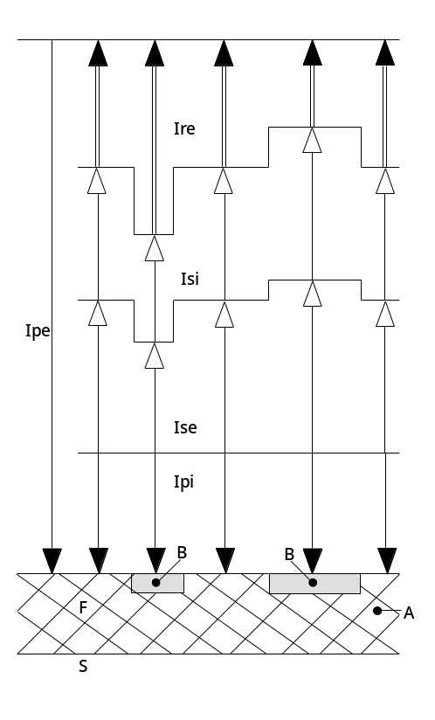 | Cross-section of conducting sample S covered with heterogeneous insulating film.  Diagram shows how different intensities may vary from one point to another over sample surface in negative ion mode:  Ipe auxiliary electrons  Ipi primary positive ions  Ise secondary electrons  Isi negative secondary ions  Ire reflected electrons

VARIATION OF THE ELECTRONIC YIELD AS A FUNCTION OF THE IMPACT ENERGY OF THE PRIMARY ELECTRONS

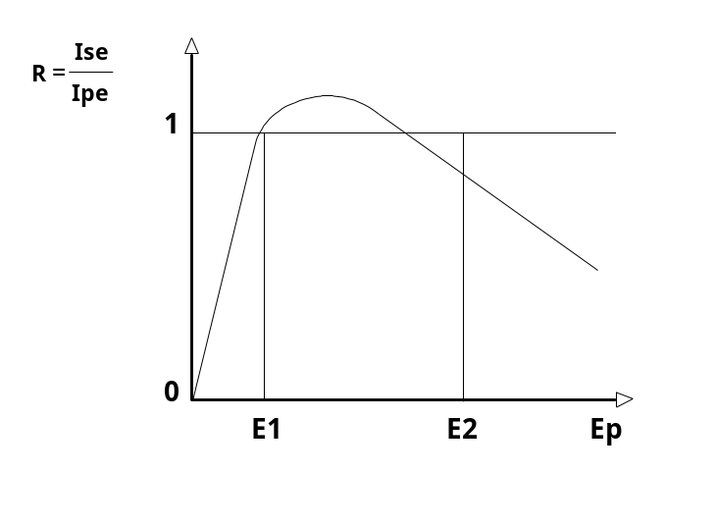

Coated Sample:

q Introduce the insulating sample into the sample chamber.

q Move the sample stage to put the insulator in the analysis position.

q Adjust the secondary magnetic sector to collect 16O- ions.

q Switch ON the primary beam on the sample surface.

q Looking at the direct ion image, center the primary beam on the secondary optical axis.

q Set the raster size at 100 x 100 µm.

q Adjust the contrast aperture position and fine immersion lens focus to get a good ion image.

q When the conductive coating has been sputtered, adjust the mass spectrometer to image a matrix species.

q Close the energy slit to have an energy band pass of 5eV or less. In that case, every small variation of the surface potential (within a few volts) involves contrast on the direct ion image. Then, using B2, B3, Quad e- it may be attempted, if necessary, to improve the homogeneity of the secondary ion intensity, mainly in the crater center where secondary ions will be collected. It must be emphasized that the adjustments have to be carried out very carefully (small amplitude variations of each parameter) to avoid involving strong charge-up effects.

q Open the energy slit to the right value for analysis.

q Move to a fresh area and start the analysis.

Uncoated Sample:

When an insulating sample is fitted into a sample holder, the equipotential lines do not remain parallel to the reference plate of the sample holder, but they will be distorted as represented below on the sketch Equipotential lines. The -5000V equipotential is therefore underneath the insulating sample surface.

Let us here assume an insulator thickness such that the surface potential is -4900V (see below the figure Procedure to switch ON the electron beam). The primary beam being OFF when the electron beam will be switched ON, electrons will not be reflected by the sample surface because the -5000 V equipotential is underneath the surface.

In fact, they will strike the sample surface with energy of 100eV. In that case, as it has been shown, there are more secondary electrons leaving the sample than primary electrons incoming; a positive charge is therefore building up, sometimes until high voltages breakdown. To avoid this charging effect before switching the electron beam ON, the sample voltage has to be adjusted to keep the -5000V equipotential above the sample surface.

The procedure to start an analysis for an uncoated insulator is as follows:

q After having performed routine NEG adjustment, switch OFF the electron beam by clicking e- ON.

q Move the stage from the grid test sample to the uncoated insulator.

q Then, apply a very negative offset on the sample holder (for example, -125V). This will bring back -5000 V equipotential above the sample surface (see below the figure Procedure to switch ON the electron beam ).

q Move the sample stage to set the insulator in the analysis position.

q Switch ON the electron beam. As -5000V equipotential is above the sample surface, electrons are reflected before reaching the sample surface.

q Go back to the nominal value -5000V on the sample holder by steps of less than 10V or continuously. Electrons following the -5000V equipotential lines are therefore approaching the sample surface. When the insulating surface is at -5000V, electrons reach the surface with low energy, and from this moment until applying -5000V on the sample holder, the area illuminated by electron beam is kept at the constant potential -5000V (see below the figure Procedure to switch ON the electron beam ).

SCHEMATIC REPRESENTATION OF THE EQUIPOTENTIAL LINE
DEFORMATIONS WHEN AN INSULATING SAMPLE IS FITTED INTO THE
SAMPLE HOLDER

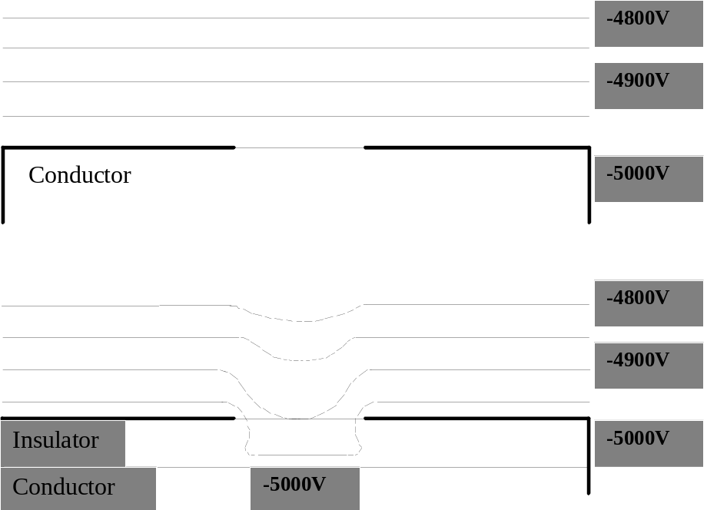

PROCEDURE TO SWITCH ON THE ELECTRON BEAM FOR AN UNCOATED
SAMPLE (1: Insulator 2: Conductor)

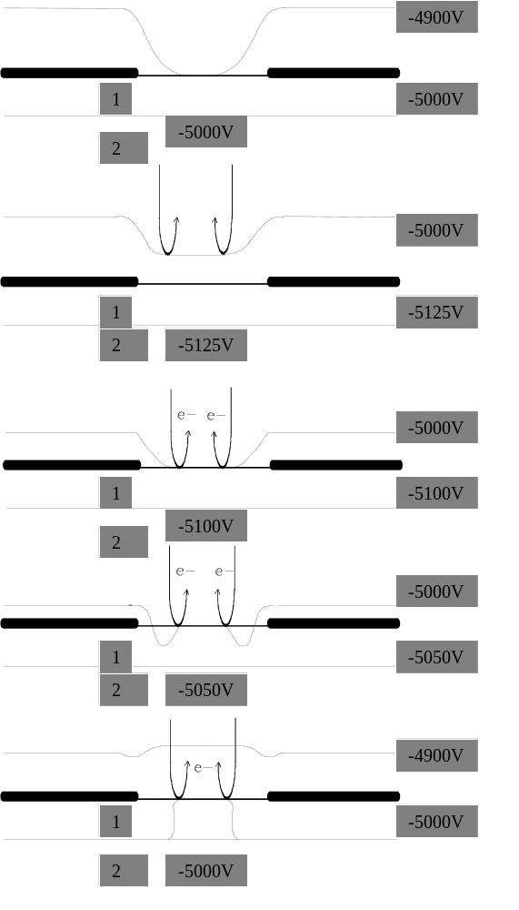 | a) Reset HV sample  b) Apply negative offset  (-125 V) and then switch  ON e- beam  c) Go back to the nominal HV sample -5000 V, step by step.  (For example: 10 V)

q Select a static primary beam (no raster).

q Switch ON the primary beam on the sample.

q Center the primary beam on the secondary optical axis.

q Select a raster size of 100 x 100 µm2.

q Perform a final tuning of charge compensation as described for uncoated sample.

q Switch OFF the primary beam.

q Move the sample towards a fresh area and start the analysis.

? Notes: Sometimes, depending on the insulator thickness, the -5000 V equipotential is so deep underneath the surface that the larger offset applied with the offset program is not high enough to bring back this equipotential above the sample surface. In that case, a less negative sample voltage must be used.

If an HV sample breakdown occurs during this procedure, the electron beam must be switched OFF before doing a reset of the sample voltage, and then, start again from the first step (apply a very negative offset...).

When charge compensation using NEG is active, it must be remembered that the surface potential of the insulating material is stabilized at the filament potential whatever the sample voltage is, so that if the energy filtering technique is required for analysis, an offset voltage on the sample holder does not modify the energy band pass (ions are still accelerated under -5 kV). Furthermore, when a multilayer sample (with alternation of conductive and insulating material) is sputtered, offset voltage technique must not be used because firstly, as it has just been shown, it would not be efficient for the insulating material analysis and secondly, at the beginning of the sputtering of insulating layer, electrons would not have an energy close to zero but fixed by the amplitude of the offset. In negative mode on insulating material, energy filtering is obtained by mechanically shifting the energy slit.

During sample holder change before opening the door between the sample chamber and the airlock system, it is recommended to switch OFF the electron beam (using either the beam blanking or the deflector). This allows avoidance of the arcing problems that may be induced by electrons having high energy (5 keV), the sample voltage being automatically switched OFF.

Sample Preparation:

If a metallic coating has been selected, a very thin layer (few tens of nanometers) is enough to start analysis without any particular precaution. Gold, Aluminum or Carbon coatings are suitable.

When metallic coating of insulating samples would involve drawbacks for quality of analysis (for example, surface contamination) it has been given a procedure to run analysis (see Coated Sample). However, it must be emphasized that the thick and the wider the uncoated insulating sample is, the more positive the -5000V equipotential line on the surface is (See below the figure Influence of the Hole Size). In some cases, the sample surface potential will be more positive than -5000V on the insulating surface. In order to maintain the -5000V equipotential line close to the sample surface, a copper grid (such as TEM) may be fitted onto insulating the material as shown below in the figure Copper Grid Set-up. Copper grid with a mesh of 250µm is suitable for most applications.

Another solution is the use of metallic aperture (thickness of 80 -100 µm, hole size 300 -500µm in diameter).

POSITIVE MODE
We have shown that when positive secondary ions are analyzed using positive primary ions, positive charge-up effects occur on the insulating sample surface. In that case, an electron flood can be used for charge compensation.

Charge compensation requirements in positive mode:
In positive mode, all electrons going through the immersion lens strike the sample surface with an impact energy equal to the sum of their initial energy (for instance 5keV if the e- gun filament is brought at 5keV) and secondary ion energy (for instance 5keV if the sample is brought at +5keV ); there are no reflected electrons. The electron beam current therefore has to be adjusted to bring the correct number of electrons to compensate the excess positive charges.

A stabilized potential surface will be obtained at:

Ipe = Ipi - Isi + Ic

Ic is conduction current flowing from the analyzed area towards a conductive material ⎯ either the substrate (for a thin insulating layer) or the vacuum deposited conducting film. Indeed, a slight conductivity of the insulator may result from the irradiation. Ic exists thanks to the irradiation of the insulator with either the electron beam, the ion beam or both. These beams create a small conductivity inside a thin layer underneath the surface.

When perfect adjustment of Ipe is performed, Ic = 0 and there is no voltage difference between the analyzed area and the conductive material. If Ipe differs from Ipi - Isi, an excess of positive or negative charges creates a voltage difference and Ic flows from the analyzed area towards the conductive material and vice versa. Ic permits equilibrium to be achieved and prevents charges from building up until breakdown in the analyzed area. It is known that Ipi is much higher than Isi, so in first approximation, to be able to perform charge compensation, the electron beam density must be at least as high as that of the primary beam.

For a filament voltage of -5000V, the electron beam current is about 40µA with a beam diameter of 700µm. The electron beam density is therefore close to 10mA/cm2. An oxygen beam of 500nA may be obtained with a density of at least 200mA/cm2. The comparison between primary beam and electron beam density clearly shows that the oxygen beam must be defocused to reduce its density to allow charge compensation. Hence, if the use of high primary beam density is required for an analysis, the electron beam density must be increased to carry out charge compensation.

By reducing the filament voltage, the resulting higher focalization effect of the immersion lens will provide improved electron beam density. Reported in the following table are the electron beam densities for different filament voltages. It appears that, for a sample holder voltage of +-5 kV, the density is higher by a factor of 7 at -1900 V than at -5000V e- accelerating voltage. The electron beam column alignment is adjusted in the same way, whatever the filament voltage is.

Sample holder H.V. | e- gun | I (µm) | ∅ (µm) | d (mA/cm2)
4,500 | 4,500 | 45 | 700 | 11
 | 1,900 | 55 | 300 | 77
 | 1,100 | 60 | 260 | 110

Experimental procedure for positive secondary ion analyses:
Standard experimental conditions are O2+ with 10.5keV energy, raster size 250x250µm2, primary beam intensity Ip = 600nA defocused over 150 µm in diameter and an electron beam current of 10 - 25µA with 9keV for energy. These experimental conditions allow one to reach a sputtering rate of about 0.2µm/min. in SiO2.

It must be emphasized that contrary to the negative mode, the dynamic transfer system cannot be used to follow the primary beam with the electron beam over the whole crater, since electrons and secondary ions have an inverse polarity. However, in positive mode, the electron beam size is adjustable between 200µm and 700µm in diameter (see the above table); thus, there is no limitation for the raster size.

In positive mode, the procedure to analyze insulating samples with or without a conductive coating is the same. It is assumed that the right electron beam alignment has been obtained following the previously described procedure, and the secondary ion optics has already been adjusted for positive secondary ion analysis.

q Before moving the sample stage to put the insulating sample in the analysis position, make sure that the energy slit is well centered on the peak of the energy distribution of secondary ions (e.g., Al+).

q Bring the insulator into the analysis position.

q Open the energy slit widely without changing the centering.

q Switch ON the primary beam with the raster size, which will be used for the analyses.

q Adjust the secondary magnetic field to collect ions for a matrix species (e.g., Si in SiO2).

q Using either the image mode or detector (EM or FC), try to find a maximum for the secondary ion intensity by adjusting the electron beam current. The electron beam current is adjusted first by using the Wehnelt effect, and, if the Wehnelt effect does not provide the correct current, modify the filament current. The drawback of the adjustment of the filament current is the waiting time for the thermal stabilization of the filament. So that, a convenient starting point is a filament current setting providing that an electron current on the sample is adjustable in the range 5 − 25µA by using the Wehnelt (Emission).

q When a maximum signal has been reached, slightly close the energy slit (e.g., 1/2 turn).

q Again, try to maximize the secondary ion intensity by adjusting the electron current.

q Repeat this procedure until the energy band pass has been reduced to a few eV.

q Looking at the direct ion image for a matrix species, and using B2, B3, Quad e-, DEFx, DEFy and Emission, try to get the best uniformity of the image.

q Open the energy slit to the correct value for the analysis. For insulator analysis, the wider the energy slit is, the lower the sensitivity to the charging effects will be.

q Move to a fresh area and start the analysis.

? Notes: It may be possible to maximize the secondary ion intensity by increasing the electron current up to the maximum intensity available (≈ 40 µm). In that case, one must either defocus the primary beam to reduce the primary beam density, or increase the electron beam density by reducing the filament voltage.

It is important to remember that each time the electron beam current is modified; the immersion lens voltage must be adjusted to keep a good direct ion image.
The centering of the energy slit should not be adjusted during this procedure.
As in the negative mode, it is recommended to switch OFF the electron beam before opening the door between the airlock system and the sample chamber.

Sample preparation:

Just as noted for the negative mode, insulating samples can be coated with a thin metallic film (Au, Al, etc...) covered with a metallic aperture or copper grid, as shown below in the figure Copper Grid Set-up.

INFLUENCE OF THE HOLE SIZE IN THE SAMPLE HOLDER FRONT PLATE ON
THE SURFACE POTENTIAL OF AN INSULATING SAMPLE

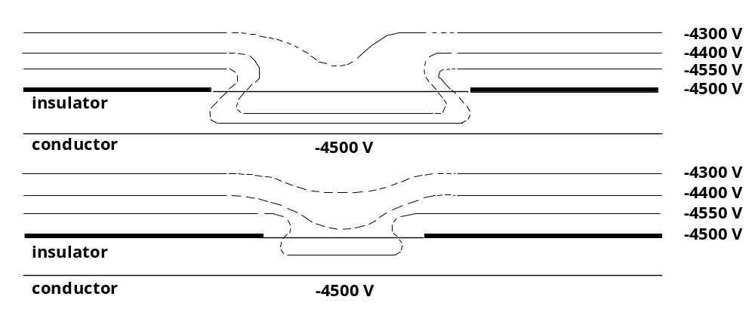

EXAMPLE OF SETUP TO PLACE A COPPER GRID ONTO THE
SAMPLE SURFACE
